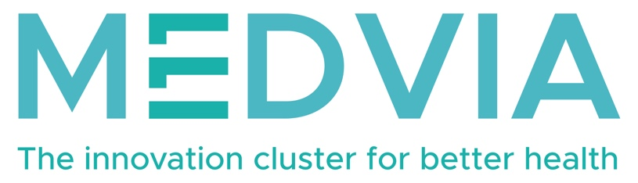

[Name], legal representative of [Company/Knowledge Institute] authorizes VLAIO to transfer all documents uploaded to the KRIS portal relating to the project [ProjectName] to MedVia in the context of the [CallNumber] call.

This is covered by the general MedVia non-disclosure agreements in the context of the call.

Signature:
Date:

