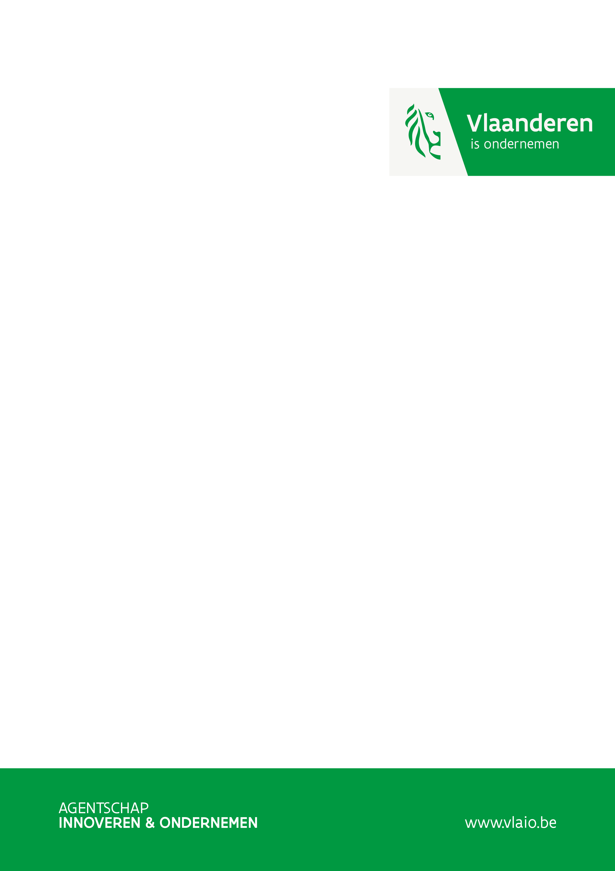

R&D Feasibility Study

Application Document

Version: July 2022

# General information and admissibility

|  |
| --- |
| *The general information includes the* ***basic data of the application****. The eligibility of the project will be determined based on this data, together with the financial information. Note the maximum page limit of 10 pages + 2 pages per additional partner. Please remember to remove the accompanying questions in italics when submitting.* |

## Executive Summary (max. 1 page)

*The executive summary should also be included in Dutch. Please include a Dutch translation of the Executive Summary right after the English Executive Summary. This does not count towards the page limit.*

**General Objective**

*Describe the essence of the intended study in 1 or 2 sentences. Describe which research questions will be examined.*

**Concrete objectives and criteria**

*Formulate the concrete objectives as verifiable as possible as well as success criteria with quantitative target values, so that after the study it can be determined to what extent the predefined results have been achieved. Describe in objectives, not activities.*

**Impact and follow-up trajectory**

*Briefly describe what knowledge and insights will be acquired. Which risks will be clarified thanks to the study?*

*Describe the intended follow-up process and its potential economic impact.*

## Co-financing

*To substantiate the co-financing of the R&D Feasibility Study, an estimate of the Net Working Capital (NWC) is requested for each partner. Please complete the table and enclose the latest income statement and balance sheet.*

**Net Working Capital (NWC)**

|  |  |
| --- | --- |
| **Net Working Capital =** | **Limited Current Assets – Short Term Debt** |
| **Net Working Capital =** | **|29/58| - 29 - |42/48| - |492/3|** |
| **Net Working Capital =** |  |

*If the calculated net working capital is insufficient to co-finance the study, long-term debt and capital already present can also be considered. Please enclose agreements as an attachment.*

# Business case and impact

* 1. Your business and innovative idea
* *Briefly describe your company activities. What do you currently offer? In which markets?*
* *Describe the subject of the study. How did the study originate? Provide a brief but clear problem statement and outline the solution that will be explored as subject of this study.*
* *If you have already taken a number of steps in the realization of your idea (e.g., market study, found a partner, investment, ...), list them briefly.*
  1. The intended study and follow-up trajectory

*The R&D feasibility study should provide better and substantiated insights into the possibilities and feasibility of an innovation. Describe the intended innovation of the follow-up process.*

* *What do you intend to achieve with this study?*
* *What are the difficulties you expect in this follow-up trajectory, which are investigated in with this study?*
  + 1. The target market
* *Briefly describe the industry the product will be targeted at. How big is this market, and how will you reach it?*
* *In which countries/regions and when will you be offering something?*
* *Describe the competitive landscape.*
* *Do you see any restrictions in the market (eg government regulations, intellectual property of competitors, …)? How do you plan to overcome these limitations? Are there favorable circumstances?*
* *Does your company (or staff) have experience with marketing of new products or services? Are you familiar with the market(s) in which your innovative idea will be offered?*
* *Describe the USP of the intended product, process or service.*
  + 1. Business model
* *Briefly describe the business model you aim for. What exactly are you going to offer your customers and at what price? Explain why these are realistic prices. How will the solution be marketed?*
* *If the business case cannot yet be described in concrete terms, give a qualitative description of the business case and position the product in the market.*
  + 1. Impact
* *Describe the economical and societal impact of the follow-up trajectory. When do you expect wich growth?*
* *Demonstrate the strategic importance of your idea. Demonstrate how the new product, process or service envisaged in the follow-up trajectory will contribute to a clear competitive advantage for your company.*
* *If your innovation leads to a social impact, you can clarify and demonstrate this here.*
* *Can you protect your results (cooperation agreement, (intellectual) property rights, user rights, …)?*

1. Knowledge leap and approach

*Chapter 1 outlined the ambitious follow-up trajectory for which this feasibility study investigates the feasibility. This chapter describes the risks, challenges and approach of the study itself. The general and concrete objectives have already been described in the Executive Summary*.

## Knowledge Leap and Challenges

* *What new knowledge will be gained during this study?*
* *What are the main technological and/or scientific challenges?*

## Approach and work program

|  |  |  |  |  |  |  |  |  |  |  |  |
| --- | --- | --- | --- | --- | --- | --- | --- | --- | --- | --- | --- |
| **Work package Number** |  | **Starting month:** | |  | | **Duration:**  **(months)** |  | | **Total Human Effort (person-months):** | |  |
| **Title work package:** |  | | | | | | | | | | |
| **Partner:** | Applicant | | Partner | | … | | | Research partner | | … | |
| **Person months *[1]*:** |  | |  | |  | | |  | |  | |
| **Subcontractor(s):** | | | | | | | | | | | |
| **Tasks**   * + *Divide the work package into tasks, with an estimate of the personnel deployment for each task, a brief description, and justify your approach. State which methods/tools/techniques/software you will use.*   **Challenges**   * + *Refer to the specific challenges you mentioned in 2.1 that are covered in this work package. Describe risks in execution and, if necessary, describe the backup plan or formulate a go/no-go decision.*   **Results**   * + *Indicate what the intended (partial) results/milestones are. What are the criteria for success?* | | | | | | | | | | | |

## Expertise

* *Briefly describe the relevant expertise of each party (your company, project partner and/or subcontractor) who will perform the above tasks.*
* *Indicate what resources (staff capacity, infrastructure, financing) you have to successfully perform the project and how you plan to compensate for any shortages in expertise and resources.*

# Added value of the aid

*Why is Flemish support important for this feasibility study? Suppose this project did not receive support, would you still carry out the study yourself and if so, what would be different? Answer this question from performing the project itself and not from the realization of your business case.*

# Project with possible military affinity (if applicable)

*More information about submitting projects with possible military affinity can be found* [*here*](https://www.vlaio.be/nl/subsidies-financiering/onderzoeksproject/voorwaarden/projecten-met-militair-tweeerlei-gebruik-dual)*.*

*If this section does not apply to your project, it may be deleted.*

*If it concerns a project with possible military affinity, you must first indicate under which section of the military list or the Dual Use list the new development falls.*

*If the project aims to realize products or systems as described in the sections of the Dual Use list, you must clearly indicate and substantiate what the expected turnover will be in the development of the business case for your project. civilian and military areas of application.*

*If the project is located under the headings ML5, ML6, ML7f-i and ML8-ML22 of the military list, or under those of the Dual Use list and the business case clearly indicates that the application is mainly military, the file for opinion submitted to the Ethics and Strategic Advisory Committee. In that case, you will be asked to do a self-evaluation during the evaluation procedure.*

# Additional information

*Your application will be assessed according to criteria that you can find in Appendix 2 of the* [*explanatory document*](https://www.vlaio.be/nl/media/1827)*. VLAIO primarily bases itself on the application document. Please fill this out clearly and completely. Especially for large and/or complex projects, VLAIO can request additional information and/or documentation.*

*When your application is being processed, there is always a meeting with a VLAIO project advisor. During this meeting, the information in the application will be discussed. Furthermore, more specific questions can be addressed (e.g., related to the business case, substantiation of costs/income, project approach, etc.).*



1. The staffing (human effort) deemed necessary for each activity is stated in person-months (pm). You can use the following conversion: 1 person-year = 12 person-months = 44 person-weeks = 210 person-days = 1596 person-hours.